**Assembly Homework 3**

**Department:** CSIE 2-B

**Student Number:** 110502567

**Name:** 蔡淵丞Vincent

**DATA SECTION:**

**array1, array2:** two arrays to pass into *CountMatches.*

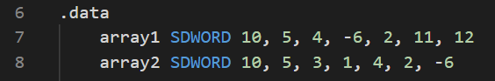

**THOUGHT:**

Use two registers to store the pointers of the arrays, and compare them. If they are equal, increase the counter (***eax***).

**MAIN PROC:**

Print out the registers before and after calling *CountMatches* to see if the registers remain the same.

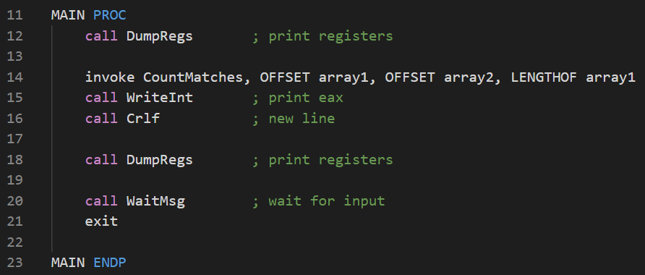

**CountMatches PROC:**

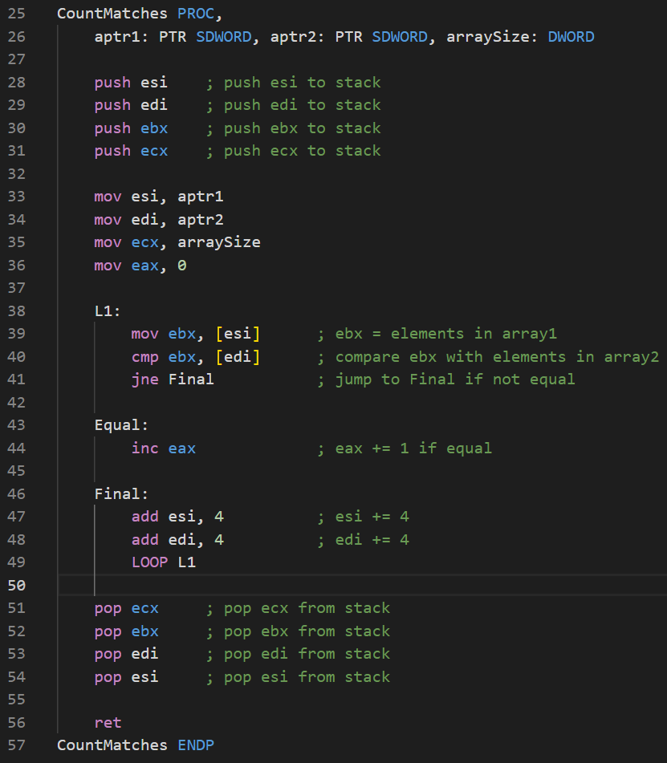

**Line 28-31, 33-36, 51-54:**

**Registers used:**

***esi:*** store the addresses of the elements in array1.

***edi:*** store the addresses of the elements in array2.

***eax:*** match count.

***ebx:*** store elements in array1 for temporary comparison.

***ecx:*** store the length of the array for loop count.

Push and pop the registers used by the procedure.

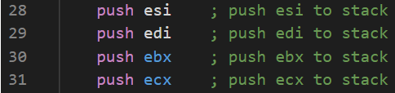

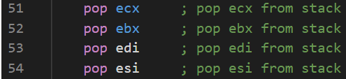

Move the arguments to registers

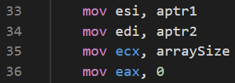

**Line 38-49:**

Move the element in array1 to ***ebx***, then compare it with the element in array2. If they are equal, then increase ***eax*** by 1. If not, increase address registers by 4, since the size of double word is 4, then loop.

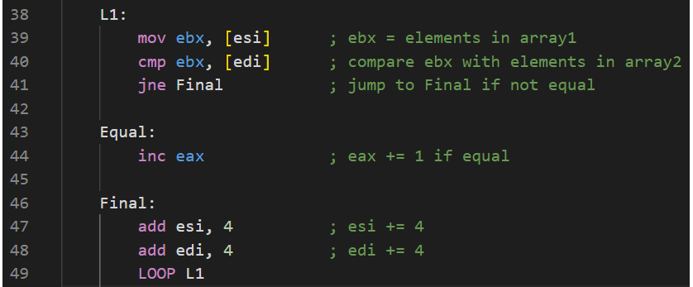

**RESULT:**

4 registers used by the procedure remains the same. And ***eax*** is correctly printed out as 2.

